Biology 12 - Circulation - Chapter Notes
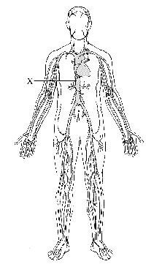Multicellular organisms (above the level of roundworms) rely on a circulatory system to bring nutrients to, and take wastes away from, cells.
- In higher organisms such as ourselves, circulation is so important that if the heart stops beating for a few minutes, death results.
- In this chapter, we will learn about the heart and how it works, plus the major vessels of the circulatory system.

The Circulatory System consists of:
- ________________ - carry blood from heart to tissues (arteries & arterioles do this) and then back to heart (veins & venules do this). Capillaries connect the arterioles to venules, and exchange material with the tissues.
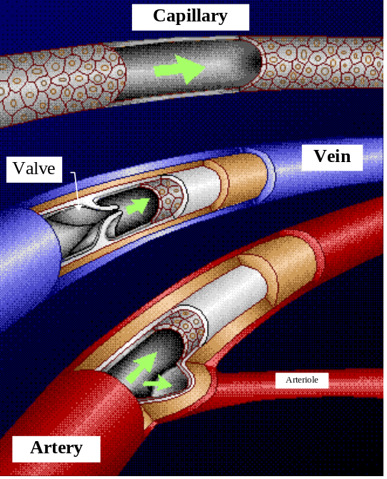
- ________________- Arteries carry ______ ______ ______ ______. They have ______ ______composed of elastic and muscular fibers (plus supporting tissue). Arteries branch into Arterioles, which are small branches of arteries that are about 0.2 mm in diameter or smaller.
- _________ - arterioles branch into small vessels called capillaries. Capillaries are very ______, ____________ tubes. The walls of these tubes are one cell layer thick. ______ and small molecules like _____ _____ across the walls of the capillaries. ______ _____ encircle the entrance to each capillary.
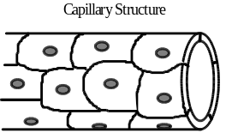
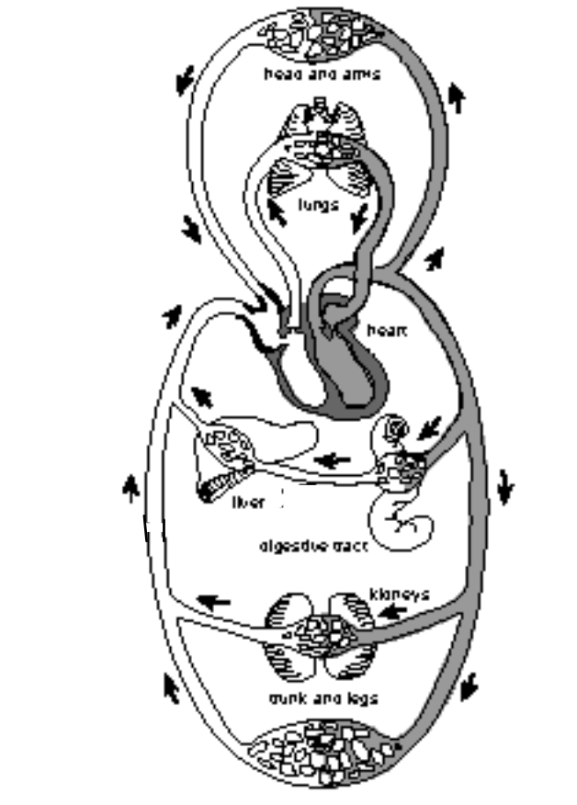
- In a capillary bed (networks of many capillaries), some, many, or most of these sphincter muscles may be closed off so that less or more blood flows to that area, as needed (e.g. more blood to muscles when they are working).
- ______ and ______ - take blood from the ___________ to the ______. Venules drain the blood from capillaries and then join to form a vein. Walls are thinner than arterial walls. Veins have ______. Valves allow blood to flow only toward the heart when the are open and prevent the backward flow of blood when they are closed.
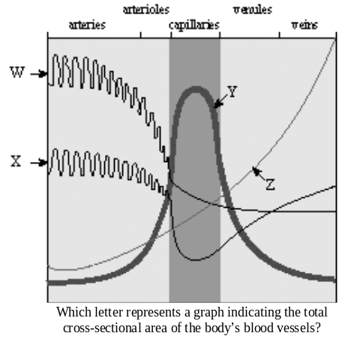
- At any one time the veins contain about 75% of the body's blood. About 20% of the body's blood is in the arteries and only about 5% is in the capillaries. You have close to 100,000 km of blood vessels!

THE HEART : 3,000,000,000 beats in an 80 year lifetime!
- The heart is a very ______ organ about the size of a fist.
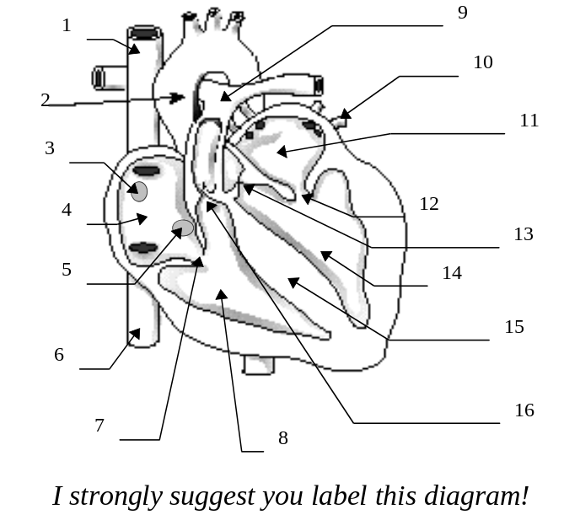
- The major portion of the heart is called the _____________, and is mostly composed of __________ muscle.
- Epithelial and fibrous tissue called ____________ covers the heart. This tissue forms PERICARDIAL SAC, in which the heart is located. The sac contains ___________ ___________.
- Think of the heart as ______ SEPARATE PUMPS: one (on the right side of the heart) pumps blood to the ______, and the other (on the left side of the heart) pumps blood to the ______ ____ ____ ______.
- The left and right side of the heart is divided by the ______.
- On each side are ______ chambers. The smaller one, located on the top, is called the ______ (plural = “atria”). The larger one, on the bottom, is called the ____________. The ______ventricle is considerably larger than the ______ ventricle because while the right ventricle only pumps blood to the lungs, the left ventricle must pump to the rest of the body.
- There are ______ between the atria and ventricles, collectively referred to as _____________________ VALVES. These valves control the flow of blood between the chambers, and prevent "__________."
- The atrioventricular valve separating the Right Atrium from the Right Ventricle is called the __________ VALVE (has 3 flaps or "cusps"), while the atrioventricular valve between the left atrium and left ventricle is called the _________ VALVE or _________ VALVE (has 2 cusps).
- Very strong, fibrous strings called the ___________ ________ support the valves and prevent them from inverting. The chordae tendinae are firmly attached to muscular projections of the ventricular wall.
- Each ventricle also has a ____________ VALVE (called that because they look like half-moons) between it and its attached blood vessels. The blood flows through the semilunar vales on its way out of the heart. The right ventricle then, has a ___________ semilunar valve (since it pumps blood out through the pulmonary artery), while the left side has an ______ semilunar valve (since it pumps out through the aorta).
- The semilunar valves have no chordae tendinae. Why do you think this is so?

THE PATH OF BLOOD THROUGH THE HEART
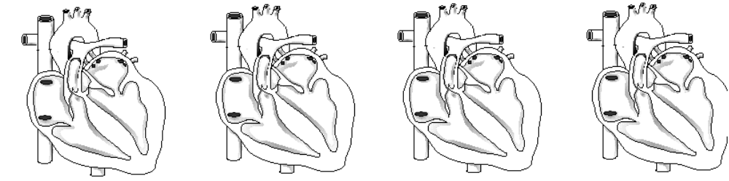
1. Blood LOW IN OXYGEN (“_____________”) enters the ______ atrium through the ___________ (top) and__________ (bottom) ________ CAVAE, the body's largest veins.
2. The ______ ATRIUM contracts, forcing blood through the __________ VALVE and into the ______ VENTRICLE.
3. The right ventricle contracts, sending blood through the ___________ SEMILUNAR VALVE and into the ____________ TRUNK.
4. The pulmonary trunk divides into PULMONARY ARTERIES, which take the deoxygenated blood to the capillaries of the _________.
5. At the lungs, carbon dioxide diffuses out of the blood, and, oxygen diffuses into it. The blood is now _____________.
6. The oxygenated blood feeds into the __________ ___________, which take it from the lungs to the ______ ______.
7. The left atrium CONTRACTS, forcing blood through the bicuspid valve into the ______ VENTRICLE.
8. The left ventricle CONTRACTS, forcing blood through the ______ SEMILUNAR VALVE into the ______, the body's largest artery.
9. The aorta divides into smaller arteries, which carry oxygenated blood to all ______ ______.

- Note that deoxygenated blood ______ _________ with oxygenated blood.
- IN REALITY, the events described above don't happen in a linear sequence. Instead, the two atria contract SIMULTANEOUSLY, and the two ventricles also _________ _________________.

THE HEARTBEAT
- The heartbeat that you can hear (the "lub-DUPP" sound) can be divided into ______ PHASES.
- First the _________ CONTRACT (the "lub" part) while the ventricles are relaxed.
- Then the ___________ CONTRACT (the "-DUPP" part) while the ______ relax.
- The actual sound you hear is caused b the vibrations of the heart when the ________ ________. "lub" = closing of ________________valves, "DUPP" = closing of the _____________valves.
- If there is a problem with a valve closing, this can cause ________ ____________.
- RHEUMATIC FEVER (caused by a bacterial infection) can cause a faulty valve (usually the bicuspid valve). Surgery or replacement with an artificial valve can often cure this.
- There are two terms that describe contraction and relaxation of heart muscle:
____________ = CONTRACTION of heart muscle.
____________ = RELAXATION of heart muscle.
- The __________ __________(= “heartbeat”) occurs about ______ times per minute, and _________ times per day in the average adult. Each heartbeat can be divided up as follows:
TIME (DURATION) | ATRIA are in... | VENTRICLES are in...
0.15 SEC. | SYSTOLE | DIASTOLE
0.30 SEC. | DIASTOLE | SYSTOLE
0.40 SEC. | DIASTOLE | DIASTOLE

WHAT CONTROLS THE HEARTBEAT?
- The heart can beat without the brain telling it what to do! That is, the heartbeat is ___________. How is this possible?
- The answer is that the heart has its own SPECIAL TISSUE, called ______ TISSUE, which has characteristics of both nerve and muscle tissue, which controls the heartbeat.
- There are ______ nodal regions in the heart:
1. SA (__________) NODE (also called the PACEMAKER): located in the upper back wall of the right atrium. The SA node INITIATES THE HEARTBEAT by sending out a signal automatically about every 0.85 seconds to make the______ CONTRACT. The SA node is called the “PACEMAKER” because it keeps the beat regular. If it doesn't work, the heart will beat irregularly. This can be corrected by implanting an ARTIFICIAL PACEMAKER, which will send out an electric signal every 0.85 seconds to stabilize the heart rate.
2. AV (______________) NODE: found in the base of the right atrium near the septum. The SA node sends its signal along fibers to the atria and also to the AV node. When the pulse sent out by the SA node reaches the AV node, the AV node itself the sends out a signal along special conducting fibers called ____________ ______. These fibers take the message to the ______________, and cause them to contract. The contraction of the ventricles begins at the base of the heart and moves up like a wave. This is because the Purkinje fibers first stimulate cardiac muscle at the base of the heart.

- While the heart can keep a steady beat on its own, the how fast it goes (heart rate) is under __________ ___________. Specifically, there is a ________ ___________ __________ in the brain (to be precise, in the __________ __________, which is an evolutionary ancient part of the brain right on top of the spinal cord).
- This center can speed up or slow down the heart rate according to the prevailing stimuli received by the ____________ ____________ SYSTEM. Various factors, such as stress, oxygen levels, and blood pressure determine how the autonomic system will affect heart rate.

VASCULAR PATHWAYS
- 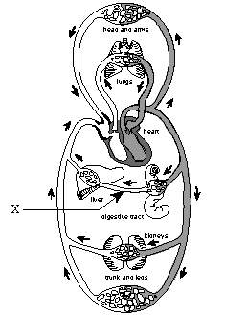As previously mentioned, the heart can be viewed as two separate pumps. Similarly, the cardiovascular system can be looked at as ______ CIRCUITS: the ____________ and the ____________ CIRCUITS.
- The _____________ CIRCUIT circulates blood through the ______, and the ___________ CIRCUIT circulates blood through body tissues.

THE PULMONARY CIRCUIT
- is the path of blood from the heart through the__________.
- deoxygenated blood from all tissues collects in the ______ ______, is pumped to the right ventricle, then is sent to the pulmonary trunk, which divides into pulmonary arteries, which divide up into the ___________ of the lungs.
- These arterioles take blood to the pulmonary capillaries, where ______ and ______ are exchanged.
- The oxygenated blood then enters pulmonary venules, then the pulmonary veins, and finally back to the ______ ______.

The Systemic Circuit
- The systemic circuit includes all blood vessels except those in the Pulmonary Circuit. It takes blood from the ______ ventricle, through the tissues & organs of the body, and back to the ______ atrium.
- in the systemic system, veins carry ____________ blood, and arteries carry ____________ blood.
- The systemic circuit contains some blood vessels you should know:
- ______: the largest artery. Branches of the aorta lead to all major body regions and organs.
- __________________________: large vein that collects blood from head, chest, and arms.
- __________________________: large vein that collects blood from the lower body regions and organs.
- ___________________________: connects the blood vessels of villi to the liver, carries nutrient rich blood to liver for processing. A portal system begins and ends in _________ (in small intestine, and other end in liver.
- ____________________carries blood from liver to inferior venae cava.

Summary of the Major Blood Vessels you Should know:
- SUBCLAVIAN ARTERY AND VEIN -= around clavicle | - JUGULAR VEIN - blood from head
- CAROTID ARTERY - neck | - MESENTERIC ARTERIES - connect to intestines
- ANTERIOR AND POSTERIOR VENAE CAVA - superior above, inferior below heart | - PULMONARY VEIN - carry oxygenated blood to left atrium
- HEPATIC VEIN - connects to inf. venae cava | - HEPATIC PORTAL VEIN - connects intestine with liver
- RENAL ARTERY AND VEIN - connect kidneys and veins | - ILIAC ARTERY AND VEIN - leads from aorta into legs
- CORONARY ARTERY AND VEIN | - AORTA - largest artery, supplies all tissues
You should also be able to describe the flow of blood around the body through any major organ. For example:
- e.g. path of blood to ______: Left ventricle ðaorta ð renal artery ð renal arterioles ð capillaries ð venules ð renal vein ð venae cava ð right atrium

__________ ______________ and ______
- these are vitally important blood vessels that supply blood to the heart muscle itself (the heart ______ ______use the blood in its inner chambers.
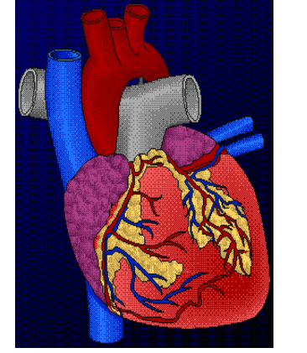
- ______ branch off the aorta just above the aortic semilunar valve, and lie on the outside of the heart.
- coronary ______ empty into the right atrium.
if a coronary artery becomes plugged (e.g. with ____________), and blood is not supplied to part of the heart, a heart attack occurs.
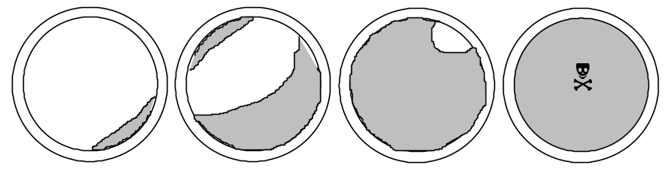
• _______________________ is a form of arteriosclerosis. Atherosclerosis is the hardening of the arteries caused by ____________ ___________ ___________. It can occur in the coronary arteries, the carotid arteries, the aorta, and the leg arteries.
- Healthy arteries are flexible, strong, and elastic. The inner layer, the tunica interna, is smooth, enabling blood to flow freely. As a person ages, the arteries normally become thicker and less elastic, and their calcium content increases. This natural "hardening" process occurs throughout the artery system. Atherosclerosis, by contrast, affects only the larger arteries.
- As the plaque builds up, the inner layers of the artery walls become thick and irregular. Fat, cholesterol, and other materials accumulate in certain areas. This gradual build-up over a long period of time reduced the circulation of blood and increases the risk of heart attack, stroke, and other serious arterial diseases.
- A person having atherosclerosis will often experience symptoms of ______, _________, and ___________ (limb pain or tiredness). All of the symptoms are caused by insufficient blood flow due to atherosclerosis.
- __________: when portion of brain dies due to lack of oxygen -- usually when arteriole bursts or is blocked by an embolism. Strokes usually cause death or paralysis.
- __________ __________: when portion of heart dies due to lack of oxygen. At first, the victim may suffer ______ ___________ (radiating pain in the left arm). Death may result if immediate treatment not given.

- ___________ __________ ___________: segments of leg veins are grafted between the aorta and coronary vessels, in order to bypass a blockage. Two to four such bypasses may be performed in a single operation. e.g. three such grafts would be known as a “triple-bypass” operation.
- Coronary bypass, donor heart transplants, and artificial heart implantation are surgical methods that have been used for the treatment of heart attacks.
- More than 50% of all deaths in Canada & U.S. are due to hypertension (high blood pressure), stroke, and heart attack.
Some more nasty circulatory events:
- ____________: a stationary clot attached to an arterial wall. Slows the flow of blood.
- _____________: a thrombus that has become dislodged and moves along with the blood. When the vessel narrows, the embolus gets stuck and entirely blocks the flow of blood in a small vessel. This is called an _____________.
- ___________ __________: abnormal and irregular dilations in superficial (near surface) veins, especially in lower legs.
- Varicose veins in rectum are called _________________.
- Varicose veins develop when the valves of the veins become weakened due to a backward pressure of the blood (often made worse by crossing legs, poor sitting posture).
- _____________: inflammation of a vein. Blood in the inflamed vessel may clot, in which case a thromboembolism occurs. If embolism here winds up in a pulmonary arteriole, blocking circulation through lungs, this is called a ___________ __________(can kill).

Pulse, Blood Pressure

- ______: the alternate expanding and recoiling of an arterial wall that can be felt in any artery that runs near the surface of the body. _________ artery in wrist, __________ artery in neck are common places to check. Pulse rate indicates the rate of heartbeat.
- ___________ ___________: the pressure of the blood against the wall of a vessel, created by the pumping action of the heart.
- _____________: lower blood pressure than usual.
- _____________: higher blood pressure than normal. Over 20% of Canadians/Americans suffer from it. Usually associated with cardiovascular disease. Many unaware they have it.
- Can be caused by diet, (e.g. high salt diet causes water to be retained) stress (causes blood vessels to constrict), and kidney involvement (renin = hormone that kidney releases to increase blood pressure by retaining salt and water).
- Atherosclerosis due to _________ _________also causes hypertension --> due to saturated fats and cholesterol. Cholesterol is carried in body by Lipoproteins. High levels of ______ ______ ___________ (LDL’s) is thought to lead to atherosclerosis.
- ______ is the most important factor. Animal products are the only source of dietary cholesterol.
- Treatments for high blood pressure include ______ __________, which prevent stimulation of autonomic nervous system. ____________ prevent arteries from constricting. ____________ cause kidneys to excrete excess salts and fluids.

Measuring Blood Pressure
- Measure blood pressure with an instrument called a _____________________________.
- ___________ BLOOD PRESSURE: the highest arterial pressure reached during ejection of blood from the heart.
- ____________ BLOOD PRESSURE: lowest arterial pressure. Occurs while the ventricles are relaxing.
- Normal resting blood pressure is ______ mm Hg over ______ mm Hg in brachial artery of arm (120/80). Of course, blood pressure ___________ with distance from left ventricle. It is higher in the arteries than in the arterioles, for example.
- Blood pressure accounts for the flow of blood in the arteries and arterioles, while __________ __________ __________________ accounts of the flow of blood in the ______ and ______.

The Lymphatic System
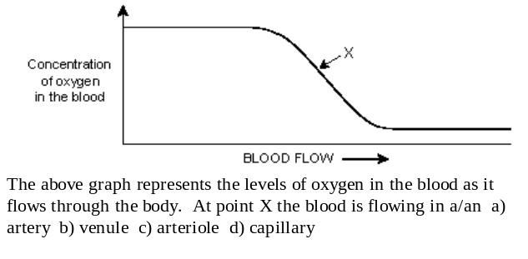
- The lymphatic system is __________ ___________ ___________in your body. It is separate from your cardiovascular system (i.e. it has its own veins and capillaries) but it is ultimately connected back with the cardiovascular system (i.e. the fluid from the lymphatic system eventually gets sent back into the bloodstream). Basically, the lymphatic system takes up excess tissue fluid (fluid that surrounds cells and tissues) from the tissues and returns it to the cardiovasular system.
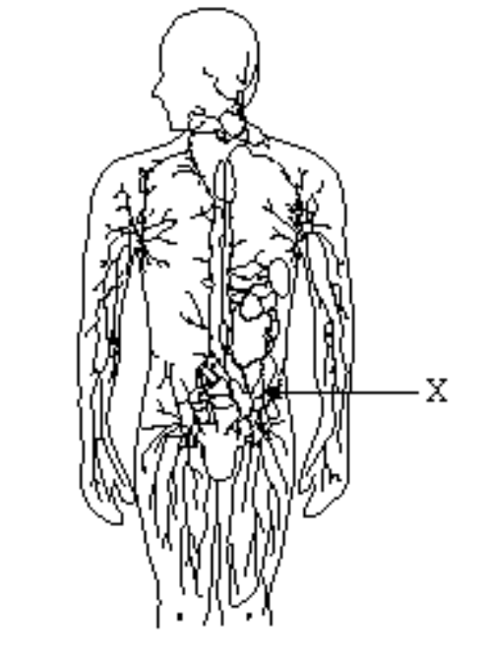
- It is a ______ ______system that starts in the tissues and empties into the cardiovascular system.
- Lymph vessels consist of LYMPH ______________ and ______ ______ (which have valves). Note: there are no lymph “arteries” since there is no “pump” in this system. Once fluid enters the lymph vessels it is called _________.
- Lymph is collected in vessels that join to form two main trunks:
- the ______ _________ ______which drains the upper right portion of the body and empties into the _________ _________ _________
- __________ ________, which drains the rest of the body and drains into the ______ ____________ __________.
- Lymph contains ___________________ which are a type of white blood cell. Some lymphocytes produce ______________.
Other Parts of the Lymphatic system you should know:
- ___________: blind ends of lymph vessels in villi of the small intestine. Products of fat digestion enter here.
- ______ ____________: small oval or round structures that occur along strategic places on lymph vessels. They produce and store ______________, and filter lymph of damaged cells and debris.
- ____________: located behind the stomach. Contains white blood cells and stores blood.
- __________ ______________: located in the upper thoracic cavity, functions in production and maturation of some lymphocytes. Decreases in size with age (may be a factor in aging).

Summary of Main Functions of Lymphatic System
1. ___________ of excess tissue fluid back to cardiovascular system
2. _____________ of ______ from the intestine and transport to blood
3. __________ ______________ by cleansing lymph and production of ____________ (a type of white blood cell). Some lymphocytes produce ______________.

Differences between Fetal and Adult Systems
- Heart develops in 3rd and 4th weeks in uterus. At end of ______ ______, the embryo’s organ systems, including heart, are functioning. During ______ ______, fetal heartbeat is loud enough to be heard with stethoscope.
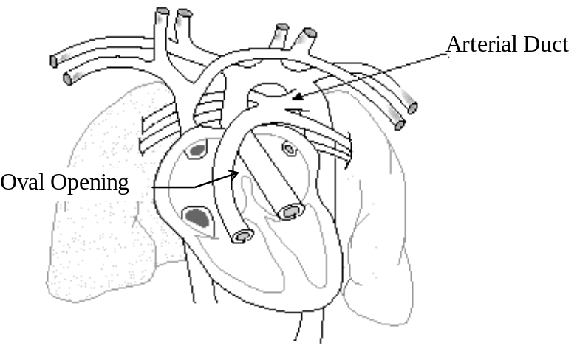
- However, the fetal circulatory system can’t be the same as the adult, if you stop to think about it. The fetus, first of all, can’t breathe air inside the womb, so sending blood to the lungs won’t do much good. Likewise, the fetus must get all its nutrients from Mom, as well as let her take care of its wastes. Obviously, some serious plumbing problems must be solved.
- To solve these problems, the fetus has ______ __________ not present in adults:

1. ______ ___________ (foramen ovale): opening between the two atria, covered by a flap that acts like a valve. Some of the blood from the right atrium is therefore pumped through this flap and into the left atrium, ___________ _________________ ______________ _______________.
- If the oval opening doesn’t close after birth, it can cause mixing of blood and “blue babies”. Correct with open heart surgery.
2. ___________ ______: (ductus arteriosus) connects ___________ ______ and ___________. Much of the blood being pumped out of the heart to the lungs will be directed away from the lungs and into the aorta. Like the oval opening, the arterial duct’s function is to bypass the pulmonary circuit.
3. _____________________________________: vessels that travel to and from ___________ (a membrane shared by the mother and baby across which gases, nutrients, and wastes are exchanged). The umbilical arteries are grafted to the iliac arteries.
4. ______ ______ (ductus venosus): connects umbilical vein to the venae cava to bring the blood back to the baby’s heart. It attaches right at the babies liver, but _____________ most of the liver. This is why chemicals ingested by the mother can seriously affect the baby!

PATH OF BLOOD THROUGH FETUS
1. Begin with blood collecting in Right Atrium
2. From there, blood can go into Left Atrium through Oval opening plus into Right Ventricle through atrioventricle valve.
3. Right Ventricle to Pulmonary Artery. Most of blood will go through arterial duct into aorta.
4. Aorta to tissue. Umbilical arteries lead to placenta, where exchange of gases and nutrients take place.
5. Umbilical vein carries O2-rich blood. It enters the venous duct, passes through liver.
6. Venous duct joins with inferior venae cava (it mixes here with deoxygenated blood) and this mixed blood goes back to the back to heart.

